*(This walkthrough has been done on an Android device – however the process is similar using Apple)*

* Open your App Store/Play Store and search for SuperLive Plus , then click Download.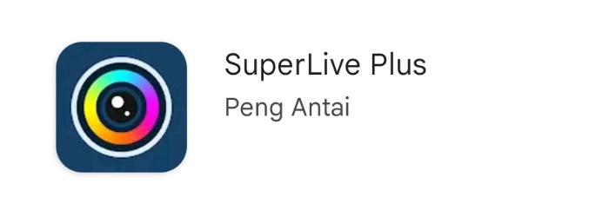
* Tick the “I have read and agree to the Privacy Policy”, then click Agree.
* 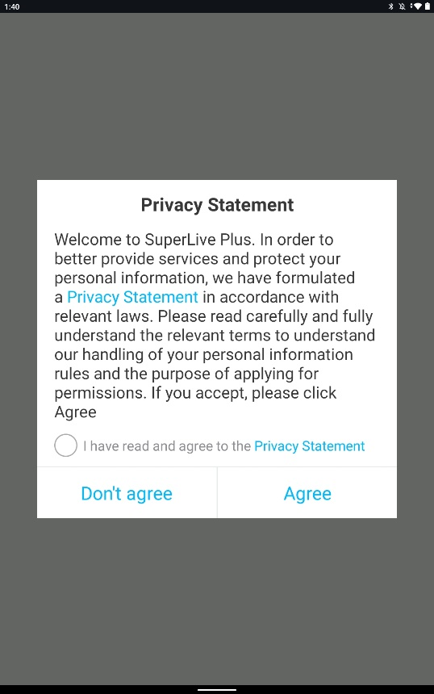
* 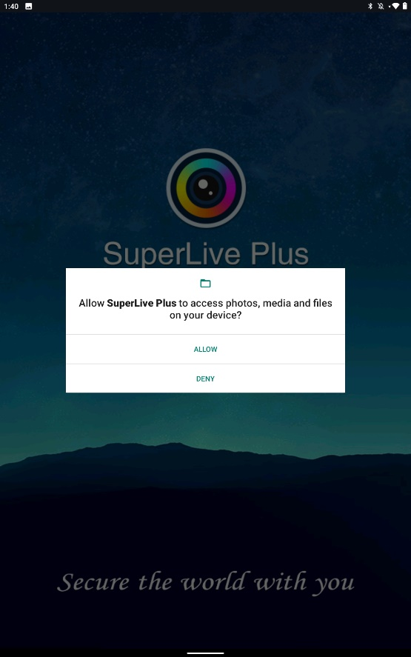 **- Click Allow**

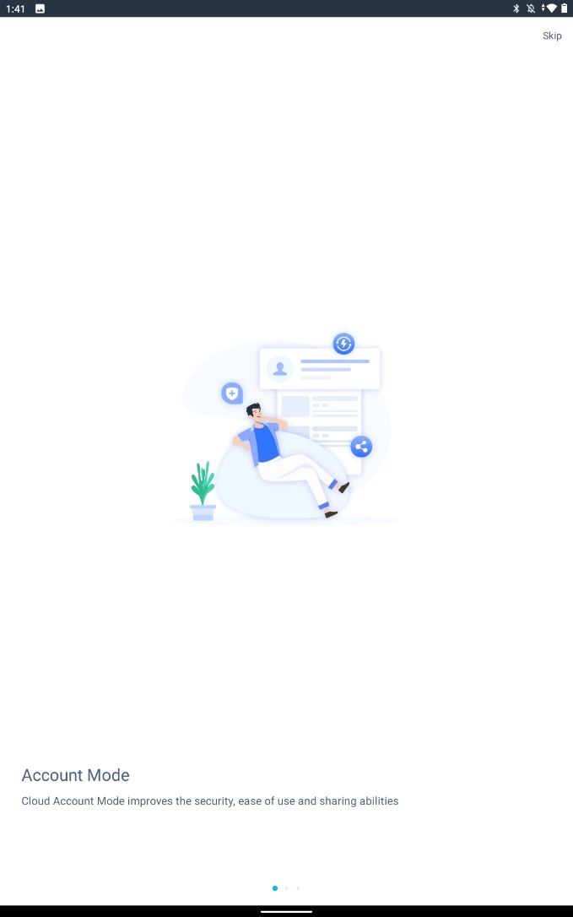 - Click Skip located in the top right corner.

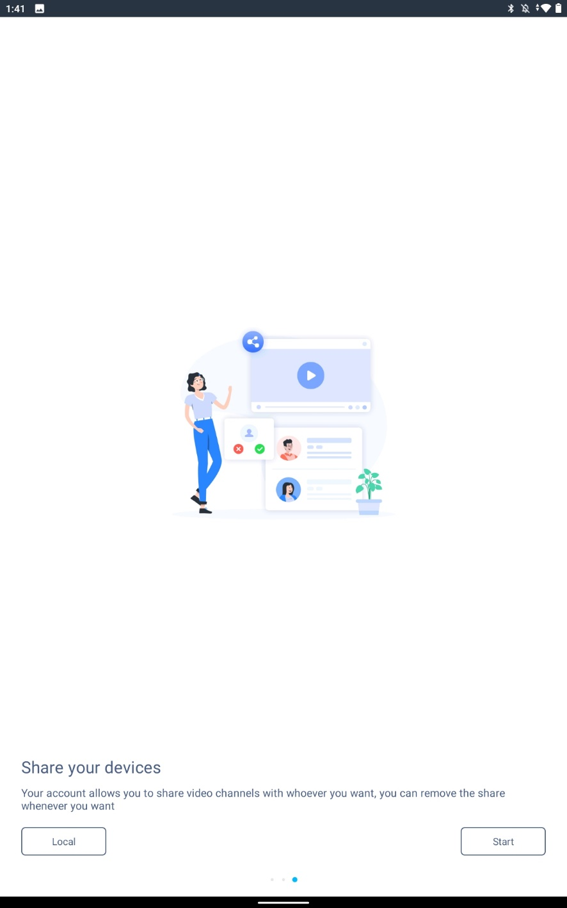 - Click Start in the bottom right corner.

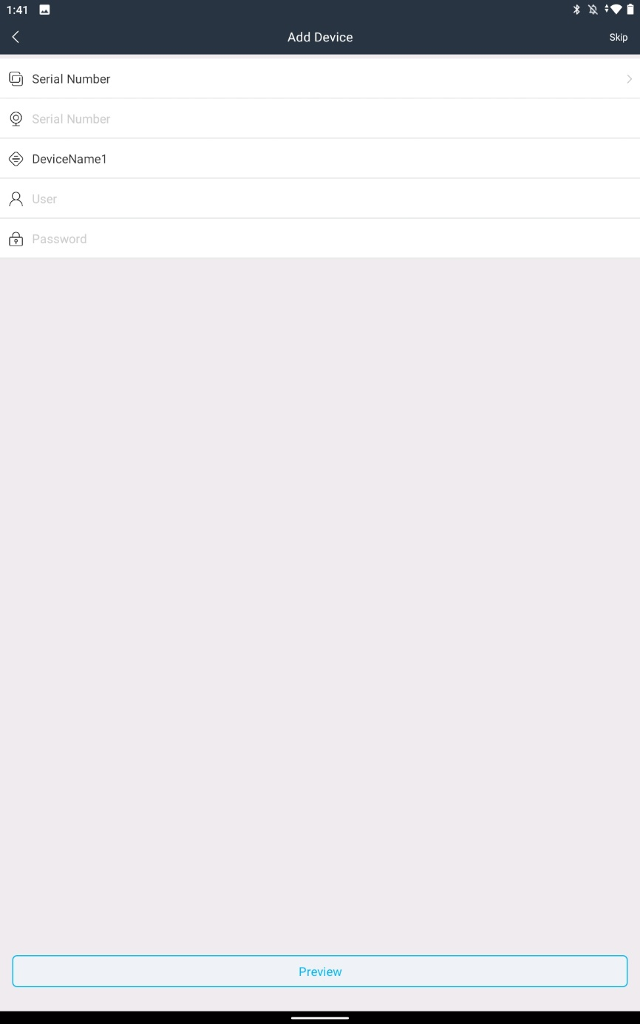 - Press Skip in the top right corner

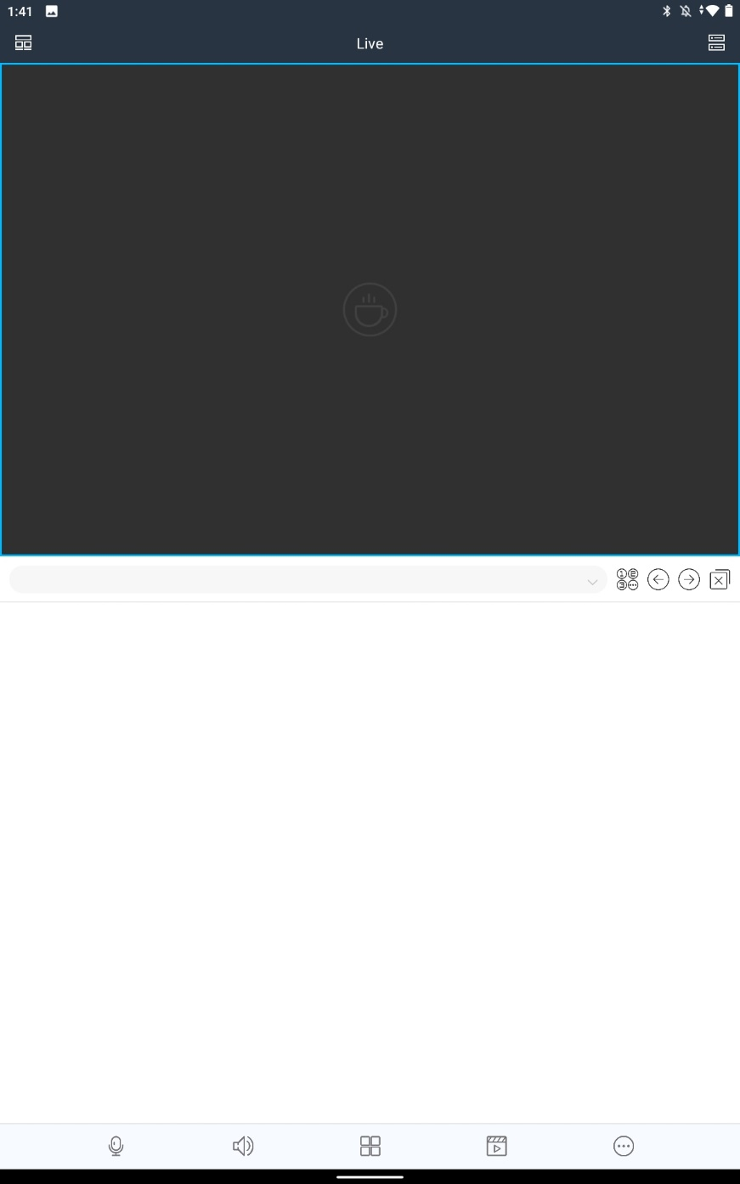 - Press the 2 Bars in the top right corner

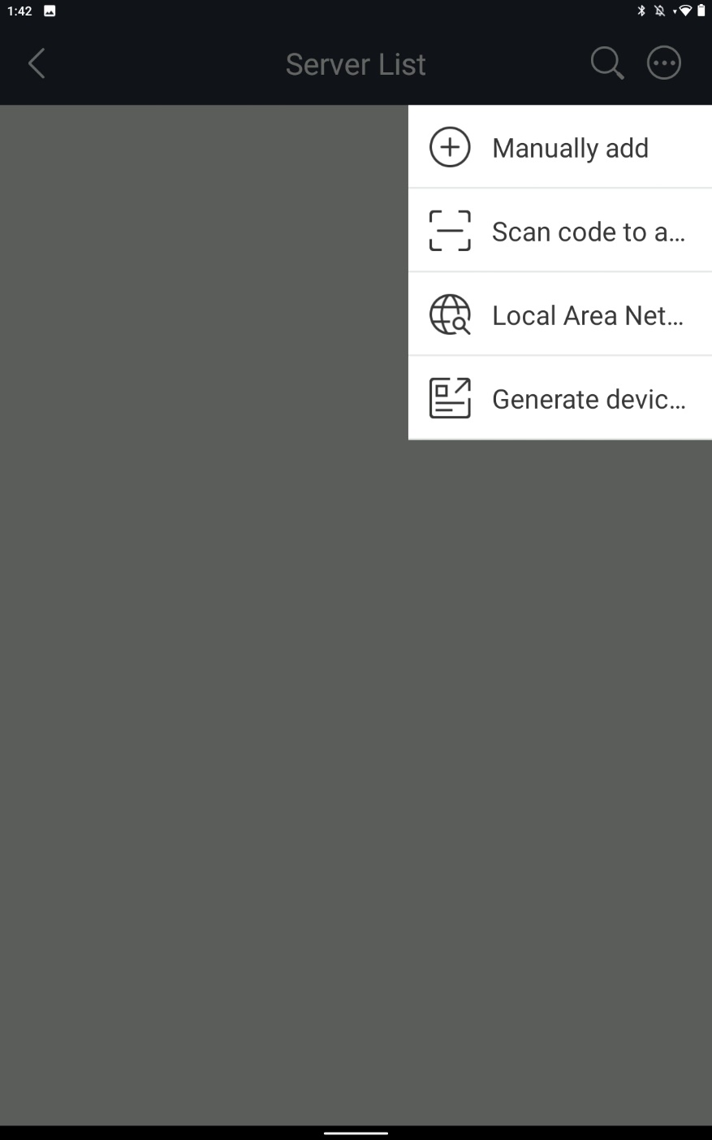 **-** Press the circle with the 3 dots in the middle, then click Scan code to a…

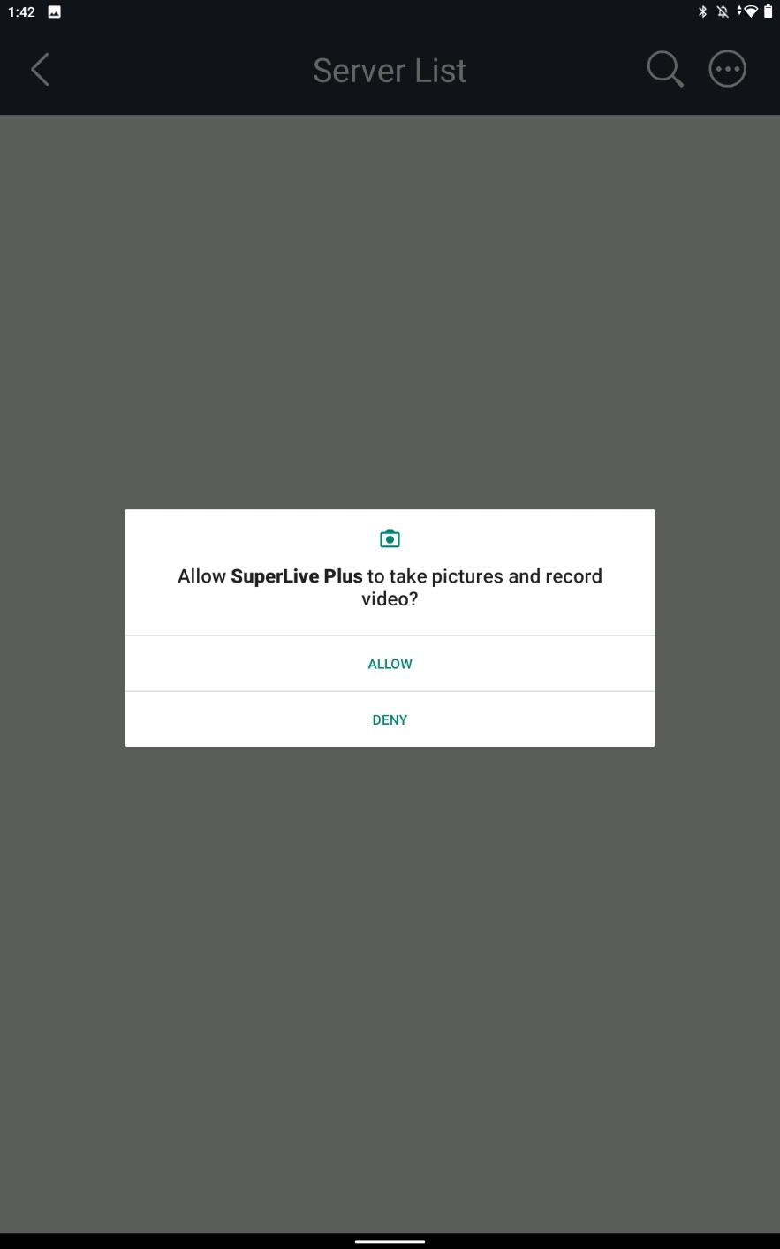 - Press Allow

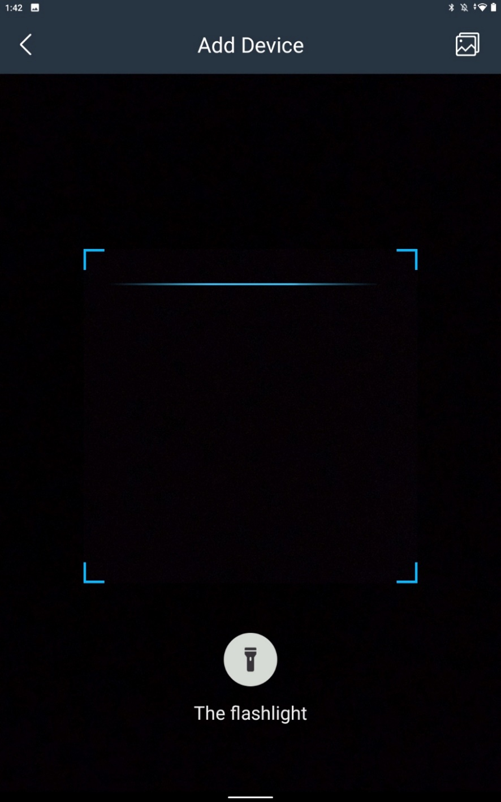  
  
  
 - Scan the QR Code provided, or if you have an image of it in your gallery, you can click the Gallery icon, located in the top right corner, locate the image of the QR Code, then upload.

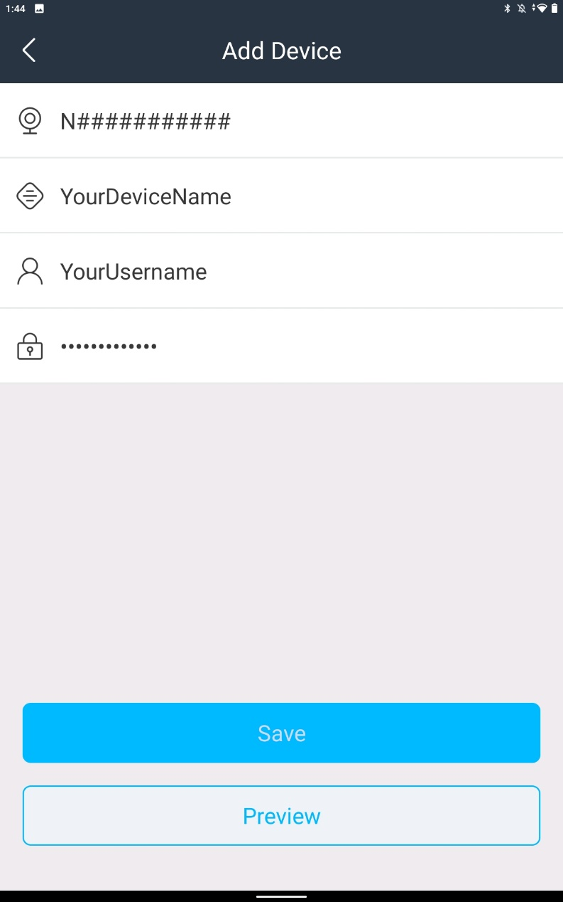   
  
- After scanning the QR Code, this screen will show. The QR code will autofill your NVRs unique serial number, along with a username.   
  
You can name the device you are adding to SuperLive (This does not need to be the same name as the device itself, this is just a local name to show on your device list.)  
  
Enter your Username provided by us.  
Enter your Password provided by us.   
  
Click Save

**Congratulations! Your device has been added!**