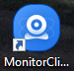  
- Look for the Monitor Client icon on your Desktop

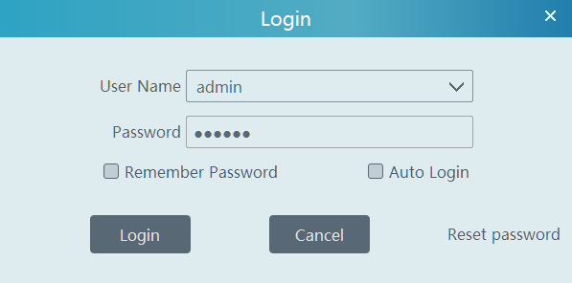  
  
- Login using the credentials provided. (THIS IS NOT THE SAME CREDENTIALS YOU USE TO LOG INTO YOUR NVR DIRECTLY!)

If no provided credentials, the credentials will be default;

Username: admin  
Password: 123456

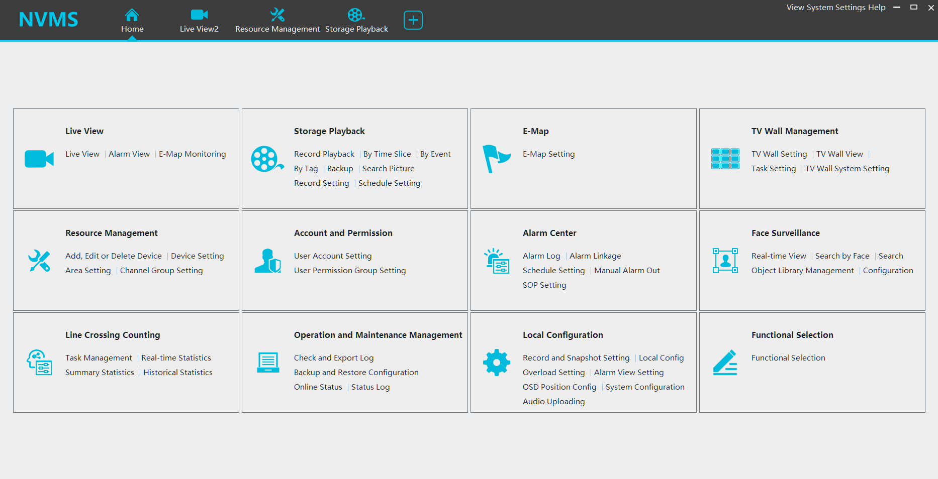

* Click Home on the top toolbar.
* Here you will see all of the different options available
* Select Live View
* At the bottom of the page you can select how many cameras you would like to view in grid.
* On the left will be an expandable drop down menu, click on the small + to expand.
* Drag and Drop your device name over to the grid view. You can also expand the device name to view each camera individually on the list.
* Your cameras will now be visible!
* Please note that if the image is slow and freezing, please select a smaller grid view and try again.

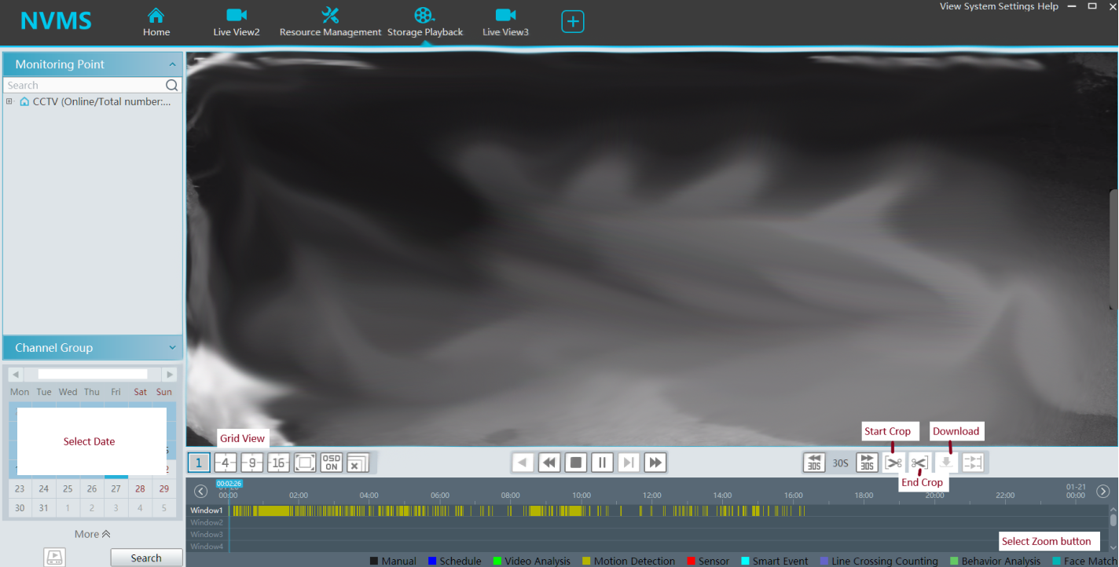  
  
Playback and save footage.

* On the home screen, select Storage Playback.
* You will now see the above image.
* Select your device name on the left hand side expandable menu, or select a camera individually, then drag and drop to the grid section.
* Double click your date, select your time. If your hover your cursor in the bottom right corner, a magnifier glass will pop up, selecting this will zoom in on the time line for a more precise time selection.
* Click Start Crop to begin cropping where the current blue line is sitting, then, click End Crop.
* The white bar will indicate the selected time you wish to back up.
* Click download
* The status bar will inform you of when the download is completed.
* Once download is complete, under Operation, click Open File Position
* This clip will require a software called **VLC PLAYER** to be played.
* If you have VLC PLAYER downloaded already, right click the file and select Open With then select VLC Media Player.